The following resources are associated:
‘Getting started in Jamovi’, ‘Checking normality in Jamovi’ and the dataset ’Birthweight.csv’

Independent t-test and Mann-Whitney in Jamovi
Dependent variable: Continuous (scale)
Independent variable: Binary (2 independent groups)
Independent t-test: Comparing means of data from two unrelated groups on the same continuous, dependent variable where the dependent variable is approximately normally distributed by group. Example: do first year graduate salaries differ by gender
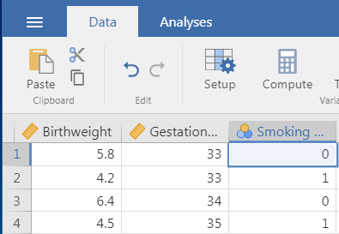
Mann-Whitney test: One assumption of the independent t-test is that the dependent variable should be approximately normally distributed. If the dependent variable is very skewed or ordinal, a Mann-Whitney test should be used instead.
Data: The data set ‘Birthweight_reduced’ contains details of 42 babies and their parents at birth. The research question is whether the mother smoking influences the birthweight of a baby, so the dependant variable is Birth weight (lbs) and the independent variable is whether the mother smokes (smoker).
0 = Non-smoker
1 = Smoker
The birthweight data set is available to download as a csv file on our ‘Practice datasets’ webpage. Download and save the csv file. Import the Birthweight dataset into Jamovi and label the smoking categories; 0 = Non-smoker, 1=Smoker through the ‘Setup’ options (see ‘Getting started in Jamovi’ sheet for help).
Assumptions for an independent t-test
Assumptions | How to check | What to do if the assumptions is not met
The dependent variable should be approximately normally distributed for each group | Use graphical methods such as histograms or QQ plots. In addition, the Shapiro-Wilk test for normality can be used but often gives significant results when the data is not skewed for larger sample sizes. For more details see the Checking normality in Jamovi resource. | If the data for either group is very skewed or you have ordinal data, use the Mann-Whitney test
Homogeneity (equality) of variance: The variances (SD squared) should be similar for all the groups | If one SD is more than twice the other, the assumption has not been met. Levene’s test for equality of variances can also be used. A significant result suggests the assumption has not been met but the test is oversensitive for moderate to large sample sizes. | If one SD is more than twice the other, the results of the t-test are less reliable. The Welch test option should be selected

Steps for the independent t-test in SAS
To carry out an independent t-test, select the ‘Independent samples T-Test’ option from Analyses T-Tests menu.

Here we are testing the hypothesis that there is no difference in birthweight between the babies of smokers and non-smokers.
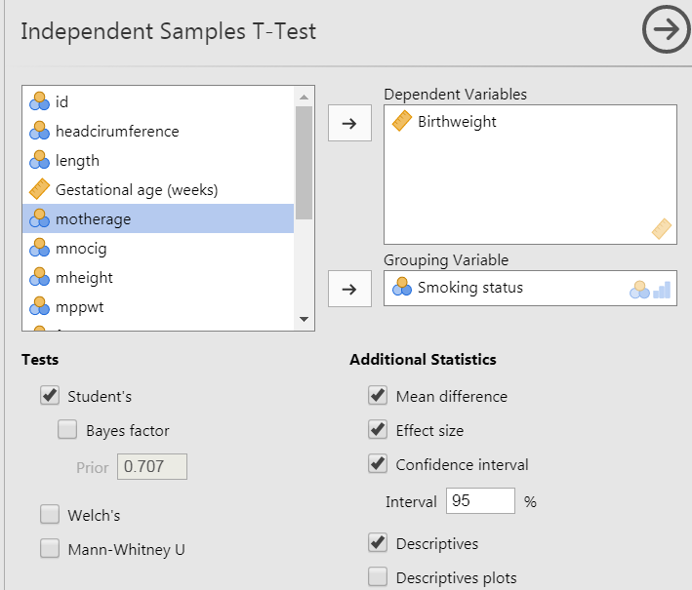

Choose the dependent variable ‘Birthweight’ from the left hand side and use the arrow to move it into the ‘Dependent Variables’ box.

Move the independent variable, ‘Smoking status’ to the ‘Grouping Variable’ box.

The ‘Student’s’ option requests the independent t-test to be carried out and is usually already selected.

Request summary statistics by group by selecting the ‘Descriptives’ option, the Mean difference between the groups and the Effect size.

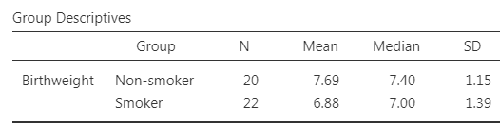
Interpretation of the output

The group statistics show that the mean birthweight for Non-smokers (7.69) is higher than for smokers (6.88).

The standard deviations are similar suggesting that there is similar spread of birthweights within each group and as the largest is not more than twice the smallest, the assumption of equal variances has been met. If the assumption has not been met, select the ‘Welch’s’ option from the test section and a new row will appear in the main t-test output.
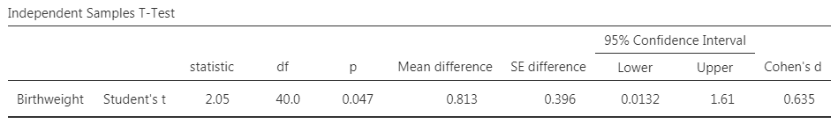

The independent t-test tests the hypothesis ‘There is no difference in the mean birthweights of babies whose mothers smoke and don't smoke’. A small p-value (under 0.05) provides evidence against this hypothesis and we say that there is significant evidence to suggest a difference in the mean birthweights. Here the p-value is 0.047 so there is evidence to suggest a difference. Follow up a significant result by explaining the difference between the groups. Here the mean difference is 0.81 lbs with a 95% confidence interval of (0.01, 1.61).

A Confidence Interval acknowledges that different samples of babies would give different results so gives a range of values within which the population mean is expected to lie. Here the 95% Confidence interval for the difference between the means (Non-smoker – smoker) is (0.01, 0.61) so in the general population we would expect the mean difference to be somewhere between 0.01 lbs and 1.61 lbs.

Another thing to consider is whether the difference in means is meaningful as with large samples very small differences will be classified as significant and with small samples, a large difference needs to be observed to be significant. Background knowledge of the subject is usually needed to decide this if a difference of 0.81 lbs is meaningful but the effect size (Cohen’s d) can be used as a guide for any variable. Cohen (1988) using the following guidelines for interpretation: 0.01 (small effect), 0.06 (moderate) and 0.14 (large effect). Here the magnitude of the differences in the means is very large (d = 0.635) so the observed difference is meaningful.

Want to know how the numbers in the output are calculated? This guide explains this for key statistical tests: https://www4.uwsp.edu/psych/cw/statistics/textbook.htm

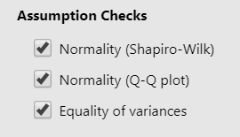
Checking the assumptions for this data
There are two checks for normality (Shapiro-Wilk test and QQplot) and also the option for carrying out the Levene’s test for equality of variances. As previously mentioned, tests of assumptions are heavily influenced by sample size so a graphical method should be used for testing normality and the comparison of standard deviations alongside any test.

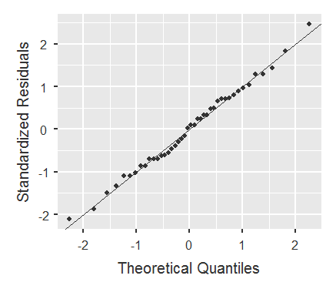 | The QQplot plot compares a perfect normal distribution (the line) with standardised observed values from both groups (the points). For skewed data, the points will clearly curve away from the line.  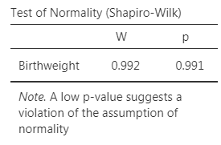  A significant result for the Shapiro indicates that the data are skewed but rely more on the plot. (see Checking normality in Jamovi resource.) The assumption has been met here but use the Mann-Whitney test if there is clear skewness.
A significant result for the Levene’s test indicates that the variances are not equal. Use the Welch adjustment to the t-test when the assumption has not been met. | 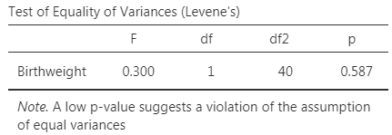

Reporting t-tests
There is evidence (t(40)=2.0545, p < 0.465) that there is a difference in the birthweight of babies whose mothers smoke and don't smoke. In this dataset, smokers have babies who weigh 0.81 lbs less on average, 95% CI (0.01, 1.61).
Mann-Whitney test in Jamovi
Dependent variable: Ordinal or continuous data which are very skewed
Independent variable: Binary (2 independent groups)
Mann-Whitney test: One assumption of the independent t-test is that the dependent variable should be approximately normally distributed. If the dependent variable is very skewed or ordinal, a Mann-Whitney test should be used instead. Note: Some disciplines use t-tests for ordinal data particularly where there are quite a few categories. It is the interpretation of mean differences which becomes tricky with ordinal data rather than the results of the test.
The Mann-Whitney U test is used to compare whether there is a difference in the dependent variable for two independent groups. It compares whether the distribution of the dependent variable is the same for the two groups and therefore from the same population. The test ranks all of the dependent values i.e. lowest value gets a score of one and then uses the sum of the ranks for each group in the calculation of the test statistic and p-value.
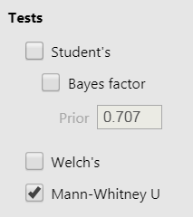
Although the assumption of normality has been met with the birthweight example above, the same data will be used to demonstrate.
Use the Independent t-test menu but select the Mann-Whitney U option instead of the automatic Student’s t-test option.

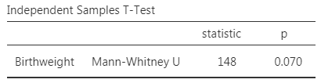

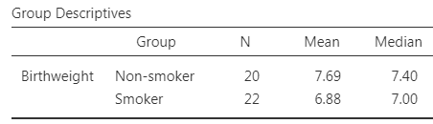
If the result is significant, means and confidence intervals are not appropriate. Instead compare medians and use a box-plot for a graphical display of the data. Medians are given in the standard output but the boxplot has to be requested through Analyses Exploration Plots Box-plot

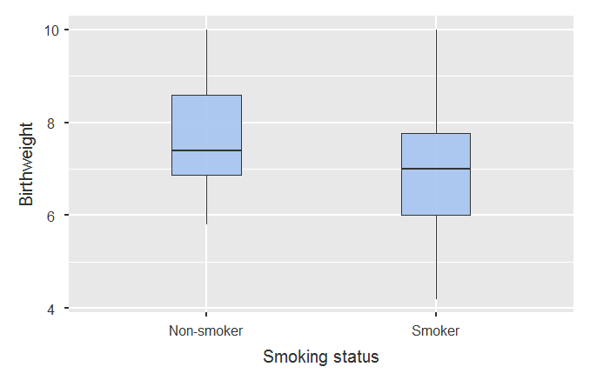
Reporting
A Mann-Whitney U test was used to test for a difference in birthweight as the data were very skewed. There was no significant difference (U = 148, p = 0.07) between the birthweight of babies born to smokers and non-smokers.

