The following resources are associated: Checking normality in Jamovi and the dataset ’Diet.csv’

One-way (between-groups) ANOVA in Jamovi
Dependent variable: Continuous (scale/interval/ratio),
Independent variable: Categorical (at least 3 unrelated/ independent groups)
Common Applications: Used to detect a difference in means of 3 or more independent groups. It can be thought of as an extension of the independent t-test for and can be referred to as ‘between-subjects’ ANOVA.
Data: The data set ‘Diet.csv’ contains information on 78 people who undertook one of three diets is available to download as a csv file on our ‘Practice datasets’ webpage. There is background information such as age, gender and height as well as weight lost on the diet (a positive value means they lost weight). The aim of the study was to see which diet was best for losing weight so the independent variable (group) is diet and weight lost is the dependent.
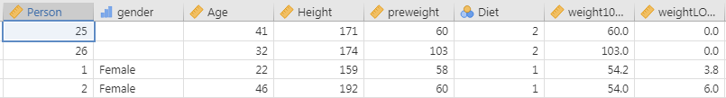
Diet 1, 2 or 3
Weight loss
Weight before

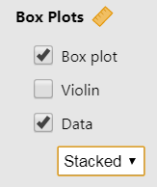
Before carrying out analysis, it is useful to visualise your data and compare summary statistics. The ANOVA procedure produces means and standard deviations of the groups but a box-plot gives a better idea of the spread of individuals within the groups and makes it easier to identifying outliers. Produce a box-plot, through Analyses Exploration Descriptives and selecting Box-plot. Jamovi has a useful feature for smaller sample sizes where all the individual points can be added to the box-plot by selecting ‘Data’.
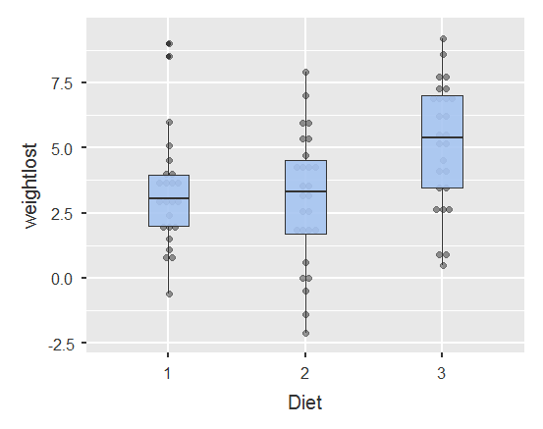
Diet 3 clearly has a higher median than the other two diets and the middle 50% is more spread out. Diet 1 has a couple of outliers who lost much more weight than others in their group and Diet 2 has some people who gained weight (have negative weight loss).

ANOVA stands for ‘Analysis of variance’ as it uses the ratio of between group variation to within group variation, when deciding if there is a statistically significant difference between the groups. Within group variation measures how much the individuals vary from their group mean. Each difference between an individual and their group mean is called a residual. These residuals are squared and added together to give the sum of the squared residuals or the within group sum of squares (SS_{within}). Between group variation measures how much the group means vary from the overall mean (SS_{between}).
Steps in Jamovi
To carry out an ANOVA, select Analyses ANOVA One-Way ANOVA
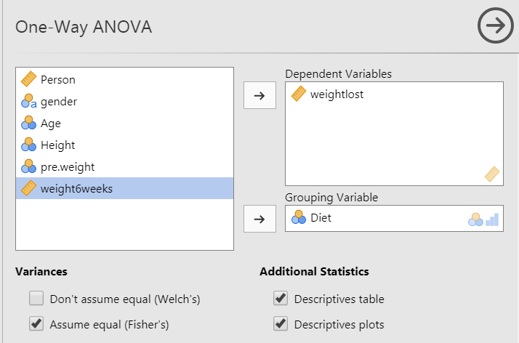
Move the continuous dependent variable (weight lost) in the Dependent Variable box using the arrow.

Move the categorical independent variable (diet) in the Grouping Variable box.

Request descriptive statistics by group and a confidence interval plot.

In the Variances section, a standard ANOVA can be requested by selecting ‘Assume equal (Fishers’s)’

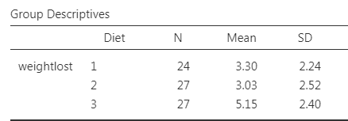
The ANOVA output

First look at the means and standard deviations of the groups and decide whether the means are similar or very different. Do the same for the standard deviations.
Diet 3 clearly has a bigger mean but all three have similar spread (standard deviations). The standard ANOVA assumes that the three groups have similar variation. If the largest standard deviation is more than twice the smallest, this assumption has not been met so go back and select the Welch’s option for the ANOVA.
The main ANOVA table is interpreted in the same whether the standard or Welch ANOVA is used.
The hypothesis being tested is that all group means are equal. A small p-value ( p < 0.05) provides evidence against this hypothesis and we conclude that there is evidence of a difference between at least two of the groups.

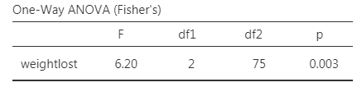
P = p-value = sig
= P(F > 6.2)
p = 0.003

F = Test statistic = ratio of $\frac{between group variation}{within group variation}$ = 6.2

When writing up the results, it is common to report certain figures from the ANOVA table.
F(df_{between}, df_{within})= Test Statistic, p = F(2, 75)= 6.2, p =0.003
There was a significant difference in mean weight lost [F(2,75)=6.2, p = 0.003] between the diets.

Post Hoc Tests
ANOVA tests the null hypothesis ‘all group means are the same’ so the resulting p-value only concludes whether or not there is a difference between one or more pairs of groups. Further ‘post hoc’ or ‘pairwise comparisons’ tests have to be carried out to confirm where those differences are and these can be selected from the Post hoc tests pull down menu.
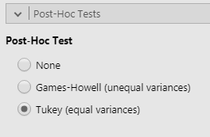
The post hoc tests are generally adjusted t-tests with an adjustment to account for the multiple testing. The options within Jamovi are:
None: Standard unadjusted independent t-test (not recommended)
Games-Howell: Use with the Welch ANOVA when group variances are very different.
Tukey: Post hoc test used when group variances can be assumed to be equal following the standard ANOVA.

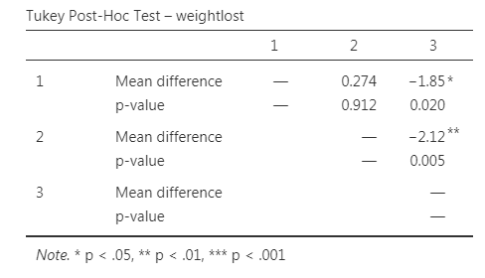
Here, the standard deviations were similar and the standard ANOVA was carried out so the Tukey post hoc tests should be selected and the mean difference between groups. The test statistics (t) and degrees of freedom can be requested and an indication of level of significance.

Report each of the three pairwise comparisons e.g. there was a significant difference between diet 3 and diet 1 (p = 0.02) and for significant differences report the mean difference between each pair e.g. people on diet 3 lost on average 1.85 kg more than those on diet 1.
Here there are three pairs tested so the results can be quickly reported but if there are lot, put the table above into a report and comment on those which are significant or of most interest.

Checking the assumptions for one-way ANOVA
Assumptions | How to check | What to do if the assumption is not met
Residuals should be normally distributed  Note: Residuals are the differences between the individual values and their group mean. | 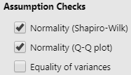 | Data should roughly fit the line in the QQplot and the p-value for the Shapiro Wilk should be above 0.05. If the residuals are very skewed, the results of the ANOVA are less reliable. The Kruskall-Wallis test should be used instead of ANOVA (see ‘Kruskall-Wallis in Jamovi’) resource  For more details on checking normality, see the ‘Checking normality in Jamovi’ resource
Homogeneity (equality) of variance: The variances (SD squared) should be similar for all the groups. | Compare the largest group SD with the smallest or use the Levene’s test for equality of variances. | If the largest SD is more than twice the smallest, the results of the ANOVA are less reliable. For the Levene’s test, a p-value < 0.05 indicates the variances are different. The Welch’s ANOVA and Games Howell post hoc test should also be used instead.

Checking the assumptions for this data
Checking normality of residuals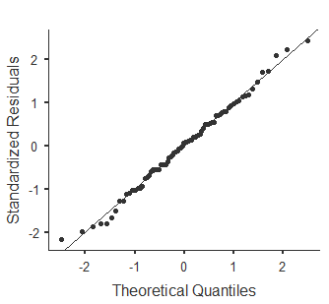 | The QQplot plot compares a perfect normal distribution (the line) with standardised observed values from both groups (the points). For skewed data, the points will clearly curve away from the line.  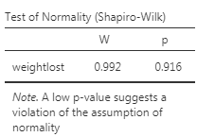  A significant result for the Shapiro Wilk test indicates that the data are skewed but rely more on the plot. (see ‘Checking normality in Jamovi’ resource.) The assumption has been met here but use the Kruskall-Wallis test if there is clear skewness.
Equality of variance  Earlier we saw that the standard deviations for the three groups were similar so the assumption has been met. The Levene’s test is also not significant confirming the assumption has been met. | 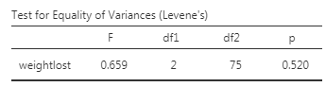  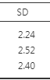  A significant result for the Levene’s test indicates that the variances are not equal. Use the Welch ANOVA and Games-Howell when the assumption has not been met.
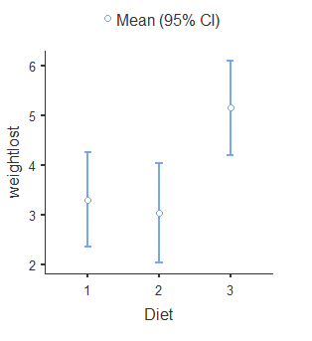

Reporting ANOVA
The key parts to report are what was used, the full results of the main ANOVA and the post hoc tests which can be reported in a referenced table particularly where there are several groups. To explain differences, a box-plot or confidence interval (shown here) can be used. The range of values we expect the population mean weight loss to be within is given by group and Diet 3 has a higher range than the others.

A one-way ANOVA followed by Tukey post hoc tests was conducted to compare the effectiveness of three diets and all assumptions were met. There was a significant difference in mean weight lost [F(2,75)=6.2, p = 0.003] between the diets. There was a significant difference between diets 1 and 3 (p = 0.02) with people on diet 3 losing on average 1.85 kg more than those on diet 3. There was also a significant difference between diets 2 and 3 difference (p = 0.005) with people on diet 3 lost on average 2.12 kg more than those on diet 2.

Other considerations
Having a large number of groups impacts on the likelihood of finding significant results particularly for the post hoc tests. If you have quite a few groups, check how many subjects are in each group and consider whether any groups can be sensibly combined. Look at group sizes and means to combine similar small groups (see ‘Creating and recoding variables in Jamovi’ resource). Another thing to consider is whether the difference in means is meaningful as with large samples very small differences will be classified as significant and with small samples, a large difference needs to be observed to be significant. Report and discuss the summary statistics and confidence intervals alongside significant results so that the reader can decide if they think the difference is meaningful as well as statistically significant.

