Reliability of scales: Cronbachs alpha
A scale is a set of ordinal Likert style questions (items) which are attempting to measure an underlying variable such as depression. Each question is given a score e.g. 1-5 and the sum or mean of these questions (items) is used to represent the underlying variable. Cronbachs alpha is a number used to check whether the questions are consistently measuring the same thing. The test assesses how similar the questions are in order to represent them reliably as one score (the mean of the questions).
In this example, we are trying to measure how much a student thinks they will struggle with learning statistics on a scale of 1(Strongly disagree) to 7 (Strongly agree). Before carrying out the analysis, check all the questions are measuring in the same direction e.g. all positive or negative. Here, the first three questions have high scores if someone thinks they will struggle learning statistics but the last question has high scores for those who believe they can study statistics. The last question need to be reverse coded so that it is in the same direction as the others.

 | Perceived struggle with statistics | Strongly disagree |  |  |  |  | Strongly agree
Variable name | Question (Item) | 1 | 2 | 3 | 4 | 5 | 6 | 7
SATStroubleSC | I will have trouble understanding statistics because of how I think
SATSnoideaSC | I will have no idea of what's going on in this statistics course
DiffUnder | I will find it difficult to understand statistical concepts
SATScanLearnSC | I can learn statistics

Calculating Cronbachs alpha
To calculate Cronbachs alpha, a column for each item is needed in the data set.
Then go to Factor Reliability Analysis to open the Cronbachs alpha window.

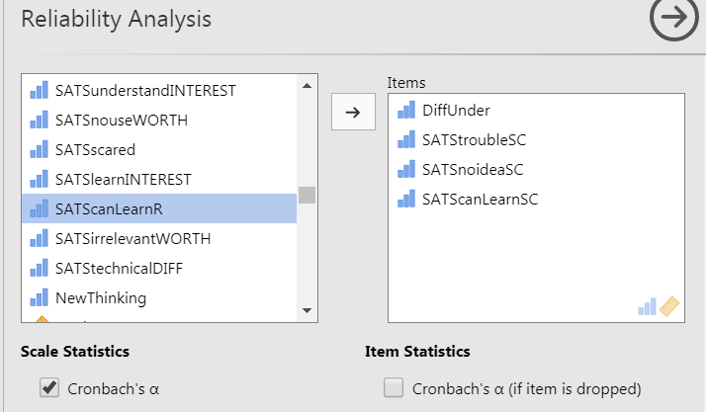

Move all the items (questions) of interest to the right hand side.

Scroll to the bottom of the section to the ‘Reverse Scaled Items’ section and click to show the variables. Move any variable that needs reverse coding to the right hand side and Jamovi will reverse code for you.
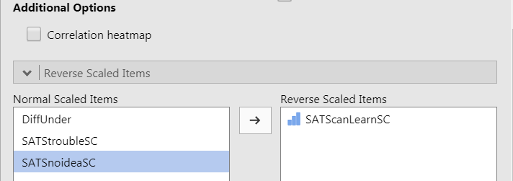

Cronbachs alpha gives a measure of how similar the questions are in order to produce a reliable measure which represents all items (individual questions). Ideally a score between 0.7 and 0.9 is obtained and you can then go ahead and use the mean of the questions instead of them individually. Here the value is 0.81 so the 4 questions
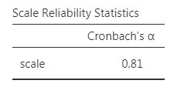

This table helps assess whether any of the questions should be removed from the scale. The last column shows what the cronbachs score would be without the individual question (item). Any items showing a large increase should be removed. The item correlation column shows the correlation between each item and the mean score for the four items. Again, any that are really low should be removed from the calculation as they are too different to the rest.
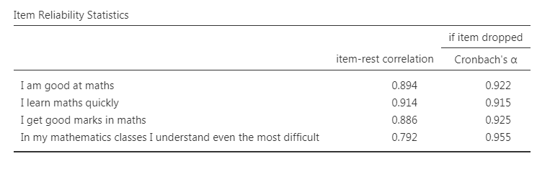

Reporting: Just say that the scale was reliable (Cronbachs alpha = 0.946) before the rest of the analysis using the mean score.

