Choosing the right test notes
Before using the online test chooser make some notes about each of your research questions using the following boxes. If you are not familiar with the terminology used, have a look at our quick guide to terminology first. It may also be useful for you to fill in the steps within the test chooser as well to keep track of what you are doing and why. There are also some notes on how to use the online test chooser on the back of this sheet.
The test chooser, paper resources for choosing the right test and terminology to help are contained on the Sheffield Hallam Maths and Statistics Support service website: https://maths.shu.ac.uk/mathshelp/TestChooser.html

Question | Answer
Research question

Dependent variable: Is there one clear dependent (outcome) variable and what is its data type?
If categorical, how many categories are there?
Other variables: Which other variables will help address the research question and what data types are they?
If categorical, how many categories are there?
Are there any repeated measures or independent (between) groups variables?
Purpose of analysis: for example, are you looking for differences, a relationship, reliability or agreement?

Write brief notes from the options you select in the following boxes:

Test selected (and non-parametric option where applicable)

Example of how to use the test chooser and notes
Many students undertaking introductory research methods courses worry that they will struggle if they don’t have A level maths. A lecturer decides to compare the final module grades for students who have studied Maths at A level and those who have not. This example shows the steps taken to choose the correct test for this research question.
Question | Answer
Research question: Is there a difference in the average research methods grade between those who have studied Maths at A level and those who didn’t?
Dependent (outcome) variable: Is there one clear dependent (outcome) variable and what is its data type?  If it is categorical, how many categories are there? |  | Yes. Dependent = final grade (continuous)
Other variables: Which other variables will help address the research question and what data types are they?  If categorical, how many categories?  Are there any repeated measures or independent (between) groups variables? |  | Independent (explanatory) variable(s) and data type: There is 1 categorical independent with two categories (binary): Studied Maths at A level or not  These are 2 independent groups of people.
Purpose of analysis: for example, are you looking for differences, a relationship, reliability or agreement? |  | Differences in the mean scores for the two independent groups.

Steps taken within the test chooser
At each stage, choose the selection that best applies to your data and then click ‘Next’ to get to the next question. At the end you will be given a suggested test and where there is a resource be taken to the relevant webpage.
Select the best option for your research question. The first option is the most common and the one selected here.
Click ‘Next’ when you have selected an option
Hover on an i to get help with an option

The steps vary depending on the path chosen but keep track of the questions answered to justify your selection.
Here the path relating to the example above is shown. The first option was selected from those above.
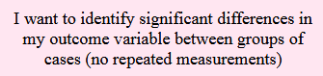
Dependent variable is continuous
1 independent variable
I am comparing two groups

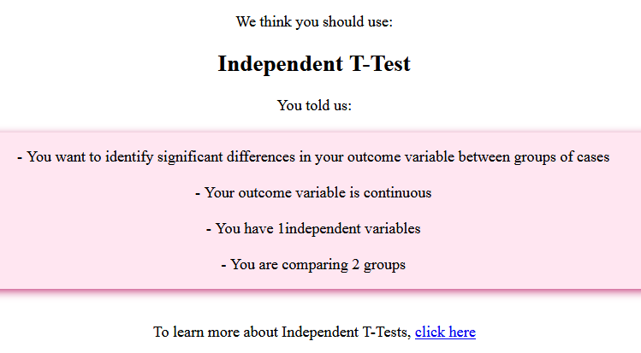
Your chosen test is here

You will get an overview of your selection here

A link will take you to the relevant webpage which gives more details and allows you to download a resource in your choice of statistical package

