The following resources are associated:
Scatterplots and correlation, Checking normality in Jamovi and the Jamovi dataset Birthweight_reduced.sav’

Simple linear regression in Jamovi
Dependent (outcome) variable: Continuous (scale)
Independent (explanatory) variables: Continuous (scale)
Common Applications: Regression is used to (a) look for significant relationships between two variables or (b) predict a value of one variable for a given value of the other.
Data: The data set ‘Birthweight_reduced.sav’ contains details of 42 babies and their parents at birth. The dependant variable is Birth weight (lbs) and the independent variable is the gestational age of the baby at birth (in weeks).

Before carrying out any analysis, investigate the relationship between the independent and dependent variables by producing a scatterplot and calculating the correlation coefficient.

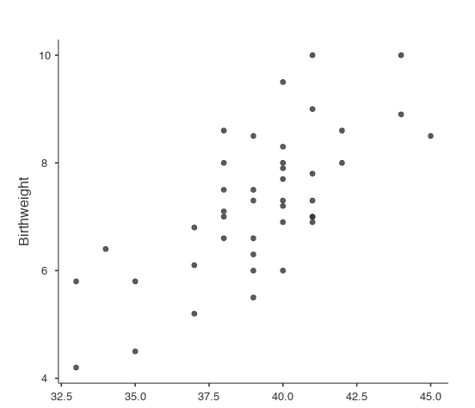
To create a scatterplot on Jamvoi you will you need to download a module named ‘Scatr’. Then select Analyses Exploration scatr

To calculate Pearson’s correlation co-efficient use Analyses Regression Correlation Matrix and move both ‘Birthweight’ and ‘Gestation’ to the variables box.

Both the scatterplot and the Pearson’s correlation co-efficient ( r ) of 0.706 suggest a strong positive linear relationship between gestational age and birthweight.
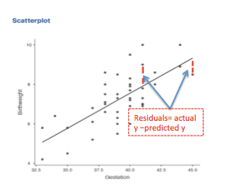
Simple linear regression quantifies the relationship between two variables by producing an equation for a straight line of the form which uses the independent variable (x) to predict the dependent variable (y). Regression involves estimating the values of the gradient and intercept of the line that best fits the data . This is defined as the line which minimises the sum of the squared residuals. A residual is the difference between an observed dependent value and one predicted from the regression equation.

Assumptions for regression
Assumptions | How to check | What to do if the assumption is not met
1) The relationship between the independent and dependent variable is linear | Scatterplot: scatter should form a line in the plot rather than a curve or other shape | Transform either the independent or dependent variable
2) Residuals should be approximately normally distributed | Request the histogram of residuals within the Plots menu | Transform the dependent variable
3) Homoscedasticity: Scatterplot of standardised residuals and standardised predicted values shows no pattern (scatter is roughly the same width as y increases)  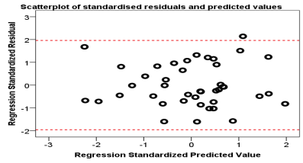 | This shape is bad since the variation in the residuals (up and down) is not constant (variance is increasing) | Transform the dependent variable
4) Independent observations (adjacent values are not related). This is only a possible problem if measurements are collected over time | Request the Durbin Watson statistic- to do this click ‘Autocorrelation test’ within the ‘Assumption Checks’ menu. It should be between 1.5 – 2.5 | If the Durbin-Watson Statistic is outside the range, use Time series (high level statistics)
5) No observations have a large overall influence (leverage). Look at individual Cook’s and Leverage values. Interpretation of this is not included on this sheet. | If you wish to check Cook’s these values can be added to the dataset via the Assumption Checks menu, select data summary and then Cook’s distance | Run the regression with and without the observations and comment on the differences
Note: The Further regression resource contains more information on assumptions 4 and 5.

Steps in Jamovi
Analyses Regression Linear Regression

Move ‘Birthweight’ to the dependent box and ‘Gestation’ to the covariates box.

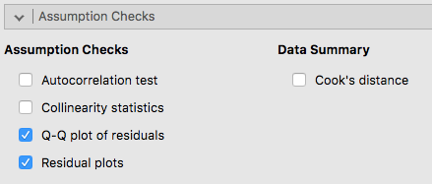
The plots for checking assumptions are found in the Assumption Checks menu. The histogram checks the normality of the residuals. There are a few options for the scatterplot of predicted values against residuals. Select Q-Q plot of residuals and residual plots.

Output
The Model Coefficients table is the most important table. It contains the coefficients for the regression equation and tests of significance.

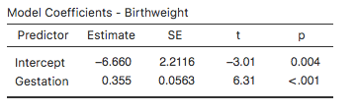

The ‘Estimate’ column in the coefficients table, gives us the values of the gradient and intercept terms for the regression line.
The model is: Birth weight (y) = -6.66 + 0.355 *(Gestational age)

The gradient is tested for significance with the test statistic (t=6.31) in the t column and the p-value in the p column. If there is no relationship, the gradient of the line would be 0 and therefore every baby would be predicted to be the same weight. The sig value against Gestational age is less than 0.05 and so there is significant evidence to suggest that the gradient is not 0 (p < 0.001).

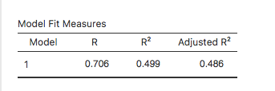
The key information from the table below is the R² value of 0.499. This indicates that 49.9% of the variation in birth weight can be explained by the model containing only gestation. This is quite high so predictions from the regression equation are fairly reliable. It also means that 50.1% of the variation is still unexplained so adding other independent variables could improve the fit of the model.

Checking the assumptions for this data
Normality of residuals  The residuals are approximately normally distributed | Homoscedasticity  There is no pattern in the scatter. The width of the scatter as predicted values increase is roughly the same so the assumption has been met.

Reporting regression
Simple linear regression was carried out to investigate the relationship between gestational age at birth (weeks) and birth weight (lbs). The scatterplot showed that there was a strong positive linear relationship between the two, which was confirmed with a Pearson’s correlation coefficient of 0.706. Simple linear regression showed a significant relationship between gestation and birth weight (p < 0.001). The slope coefficient for gestation was 0.355 so the weight of baby increases by 0.355 lbs for each extra week of gestation. The R² value was 0.499 so 49.9% of the variation in birth weight can be explained by the model containing only gestation.
The scatterplot of standardised predicted values verses standardised residuals, showed that the data met the assumptions of homogeneity of variance and linearity and the residuals were approximately normally distributed.

